Yuchen Cao, Zitong Cheng, Aaron Li

Yc3580@columbia.edu

Test plan and its Results

Group 2

Contents

Introduction 1

Test Plan 1

Test Results 1

1. All long position on the Ford Stock 1

2. All short position on the Ford Stock 5

3. All long position on the Xerox Stock 9

4. All short position on the Xerox Stock 12

5. 50% position on Ford and 50% position on Xerox, portfolio in long position 16

6. 50% position on Ford and 50% position on Xerox, portfolio in short position 19

7. 45% position on Ford and 50% position on Xerox, with 5% position on S&P 500 put options, portfolio in long position 23

8. 45% position on Ford and 50% position on Xerox, with 5% position on S&P 500 put options, portfolio in short position 26

Recommendation 30

# **Introduction**

This documentation will record test plans for the model and its result. Eight test plans are picked for illustration, followed by its test result of VaR and ES, exception counting and real loss VS VaR comparison.

# **Test Plan**

As a risk manager, with a long position in the stocks, there should be another long position in the options whose underlying’s return has a strong positive correlation with the stock’s return. Here in this portfolio, we could observe a a strong correlation between the stock and the S&P 500 index, as well as between each stock. In addition, put options are used for hedging strategy as it is not only tax-deductible, but also held as an insurance to avoid huge implied volatility in the market. Hence, the following test plan will use the put option as an example to illustrate the result.

In order to observe a comparable result, the following test plan are going to fix the observation period as 20 years, and rolling windows as five years for drift and volatility calculation.

This documentation records eight test plan:

1. All long position on the Ford Stock
2. All short position on the Ford Stock
3. All long position on the Xerox Stock
4. All short position on the Xerox Stock
5. 50% position on Ford and 50% position on Xerox, portfolio in long position
6. 50% position on Ford and 50% position on Xerox, portfolio in short position
7. 45% position on Ford and 50% position on Xerox, with 5% position on S&P 500 put options, portfolio in long position
8. 45% position on Ford and 50% position on Xerox, with 5% position on S&P 500 put options, portfolio in short position

It is expected that there is a huge spike in the exception counting between 2007 and 2008 where the subprime crisis and financial crisis occurred with a huge volatility; In addition, dot com bubble burst in 2000 where the stock market fell and then recovered, for which we may observe some spikes at that time period. The following will discuss the results in details. Also, since Monte Carlo VaR overlaps with Parametric VaR, those two exception counting should also overlap.

# **Test Results**

## **All long position on the Ford Stock**

As can been seen in the following VaR and ES, it mirrors the solutions provided before. The shape of the result makes sense due to the stock price went down at the beginning of 2000 in the midst of the dot com bubble burst, and in the middle of 2007 and 2008 due to subprime crisis and financial crisis. After Obama’s assuming the office, market has become resilient and the stock price goes up again, which suggests a lower risk and thus a lower VaR.

On the other hand, the exception counting reaches its spike of nearly 45 exceptions amid 2008 under the parametric VaR using GBM, indicating the spike of the VaR at that period. If we take a look at loss VS VaR, a huge amount of exceptions is observable at that time.

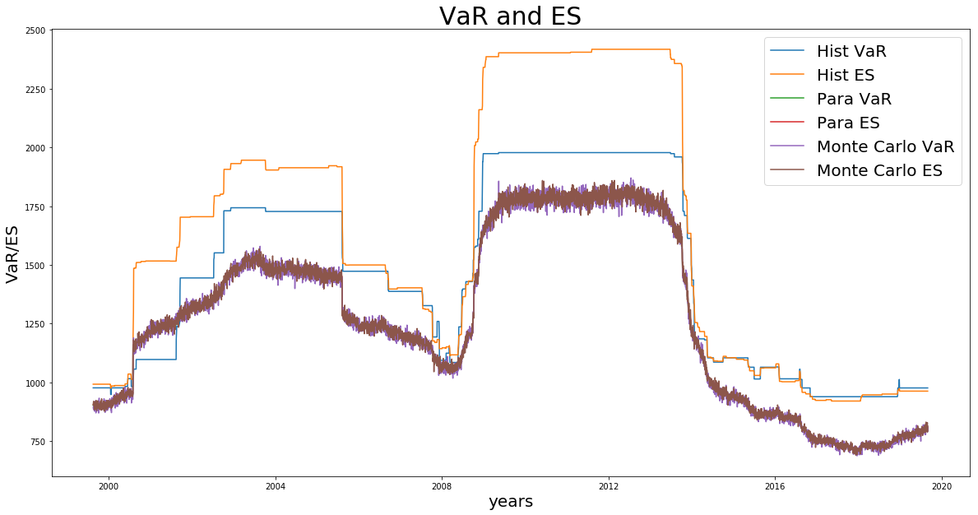

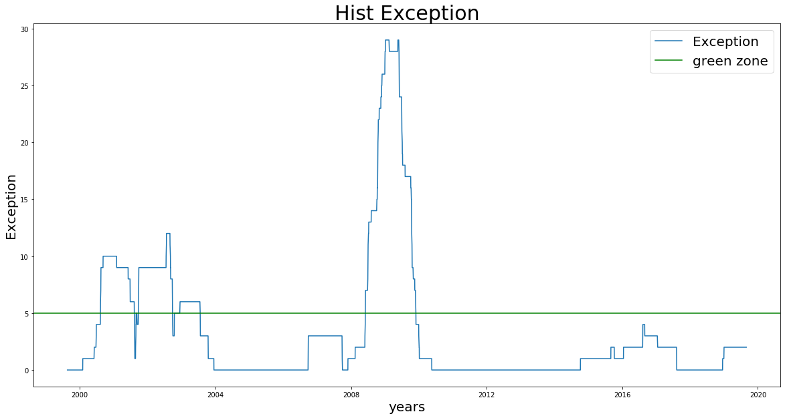

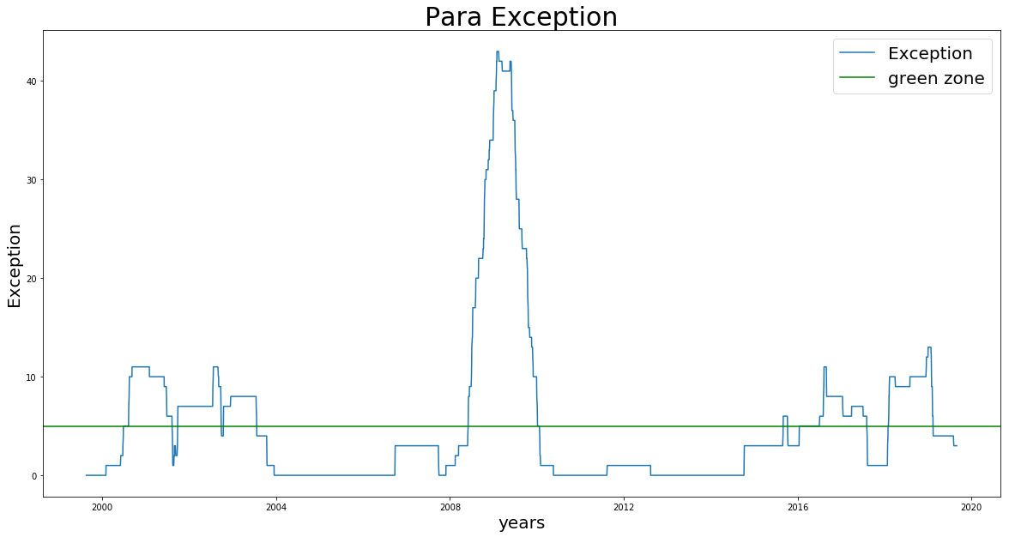

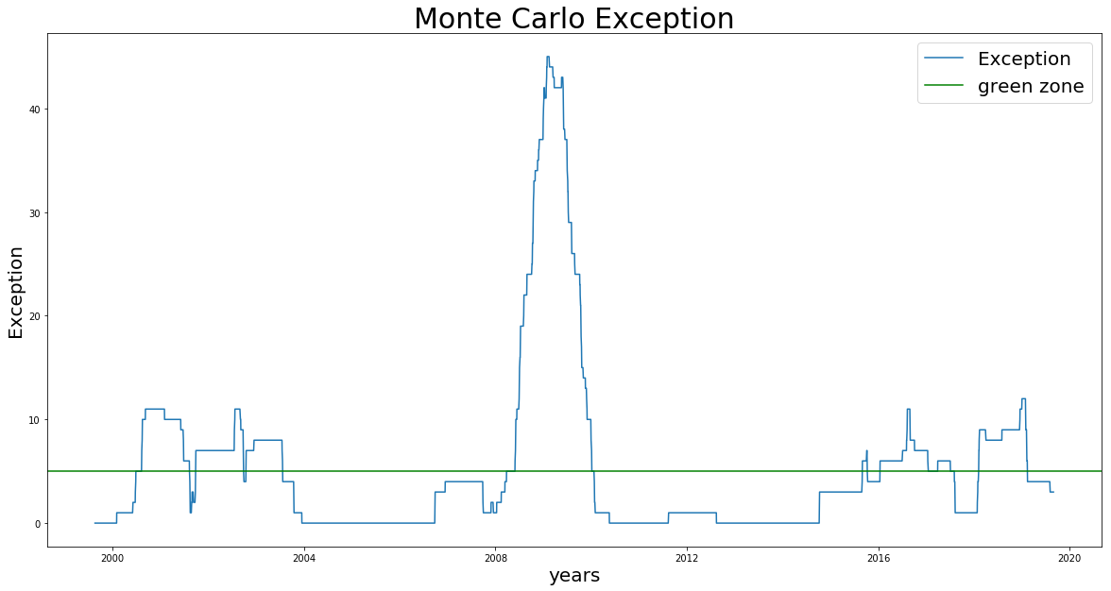

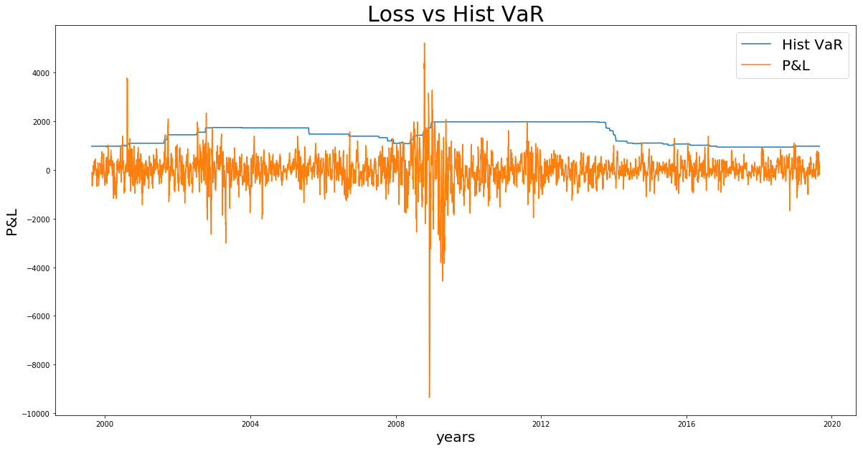

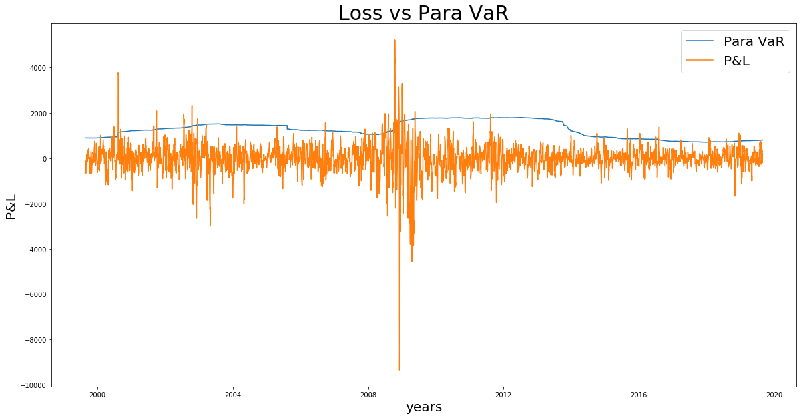

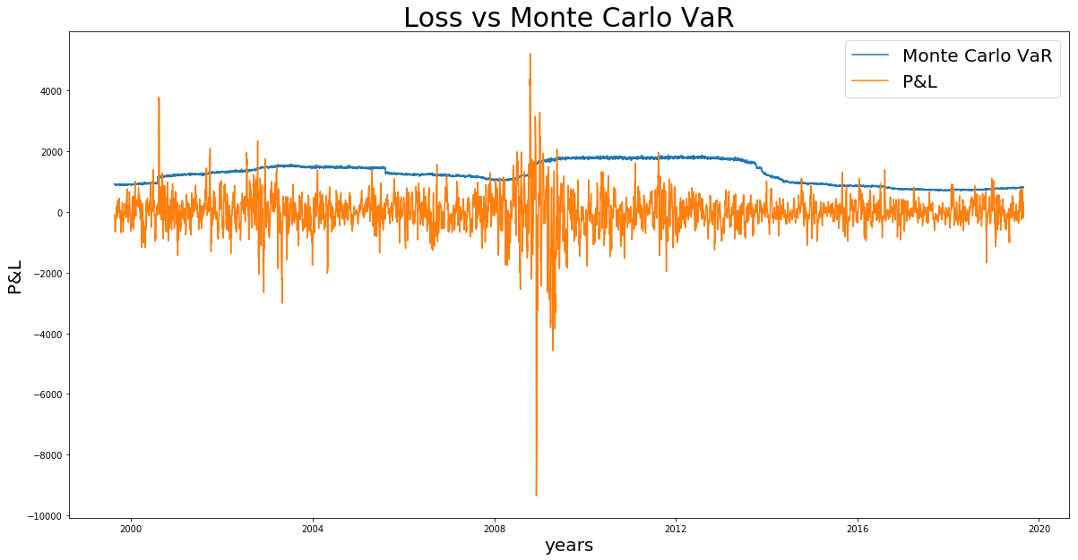

## **All short position on the Ford Stock**

The shape of the VaR and ES almost remain the same despite the amount rising. With all short position on the Ford Stock, its VaR and ES seems to be higher than the long position VaR due to the unlimited downside risk where one can lose all money as the stock price is relatively higher. The stock price went down at both period and thus losses incurred is much lower compared to the long position, as a result of which the exception counting yields a lower spike in 2001 and 2008 compared to the long position. Nonetheless, exception is still higher in 2008 suggested by loss VS VaR graph. On the other hand, the first spike appears to post dot com bubble burst, which results from the rise of the Ford’s stock price.

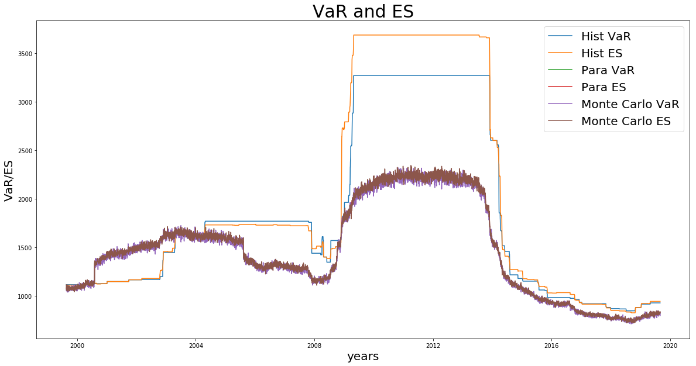

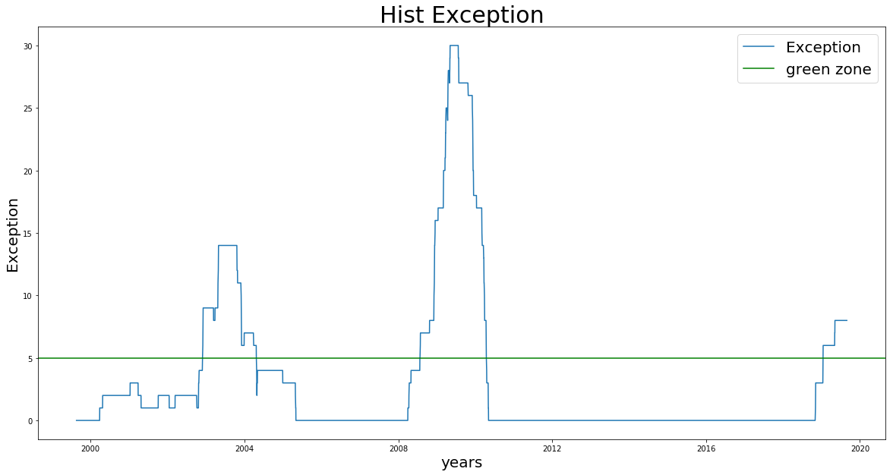

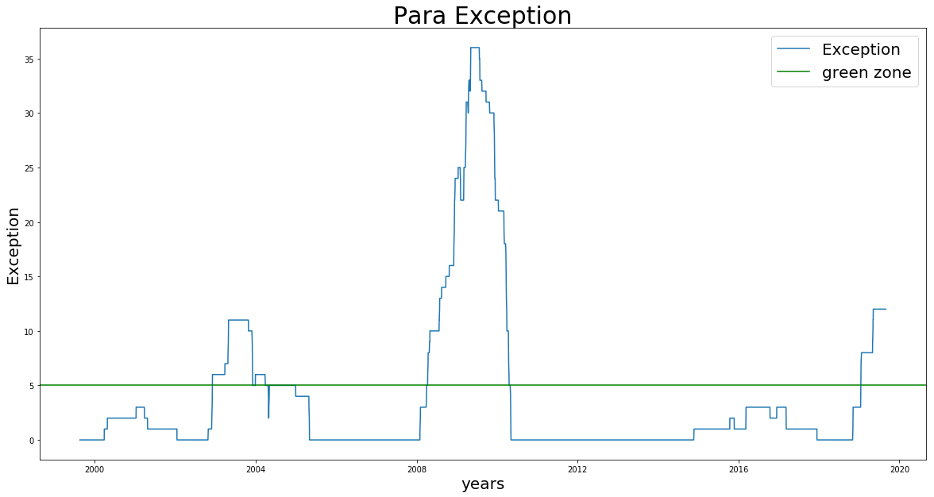

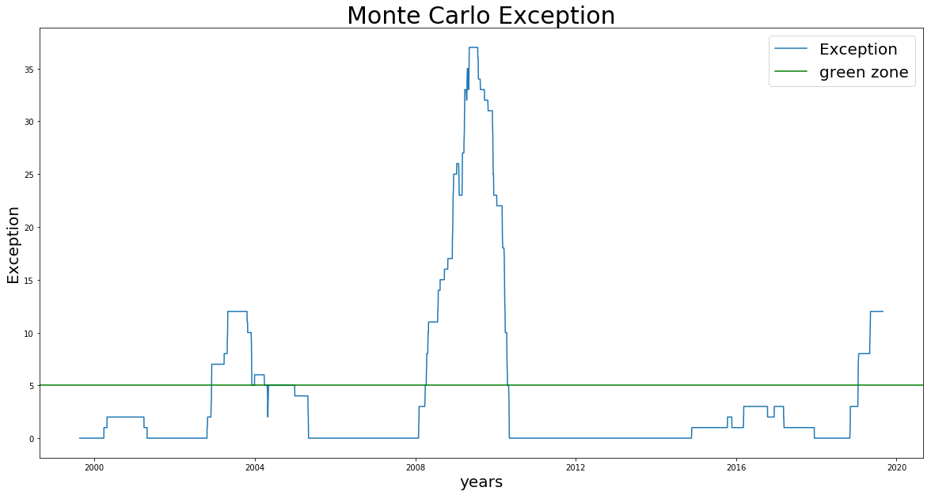

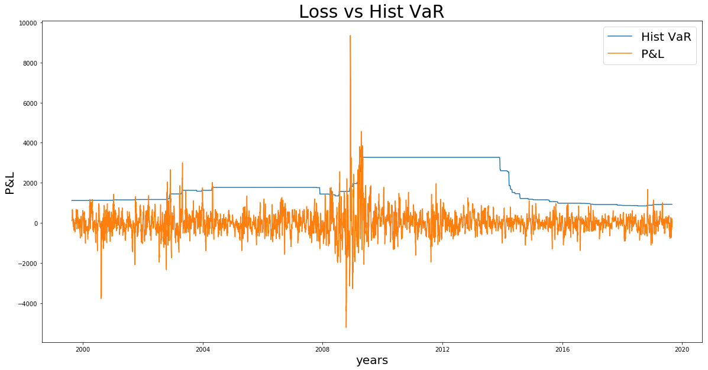

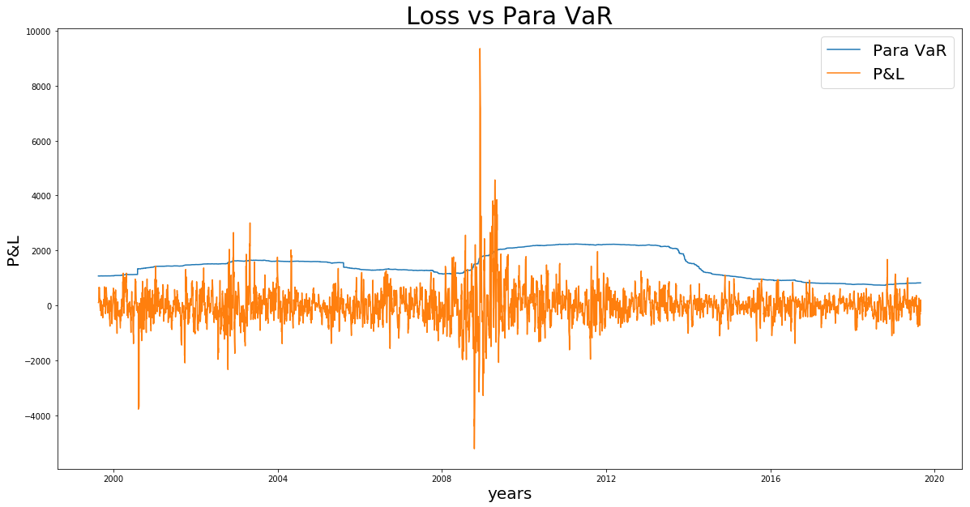

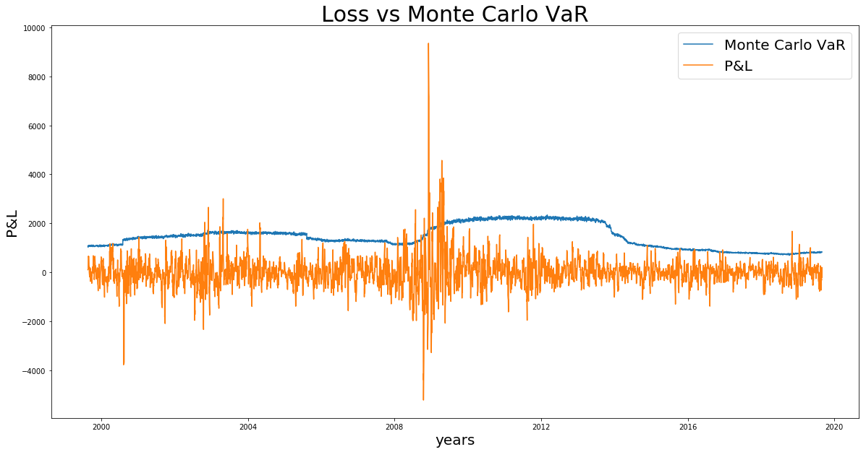

## **All long position on the Xerox Stock**

Xerox’ stock price plumped at the beginning of 2000, before the dot com bubble burst; compared to Ford’s stock prices, it results in a much higher spike at that time if in the long position; although the stock price went down as well in 2008, the relative change was not significant, which yields a lower spike during the financial crisis.

The exception counting and loss VS VaR graph suggest the ideas above. In 2000, the spike reaches 35 exceptions, much higher than Ford’s, but lower in the second spike amid 2008.

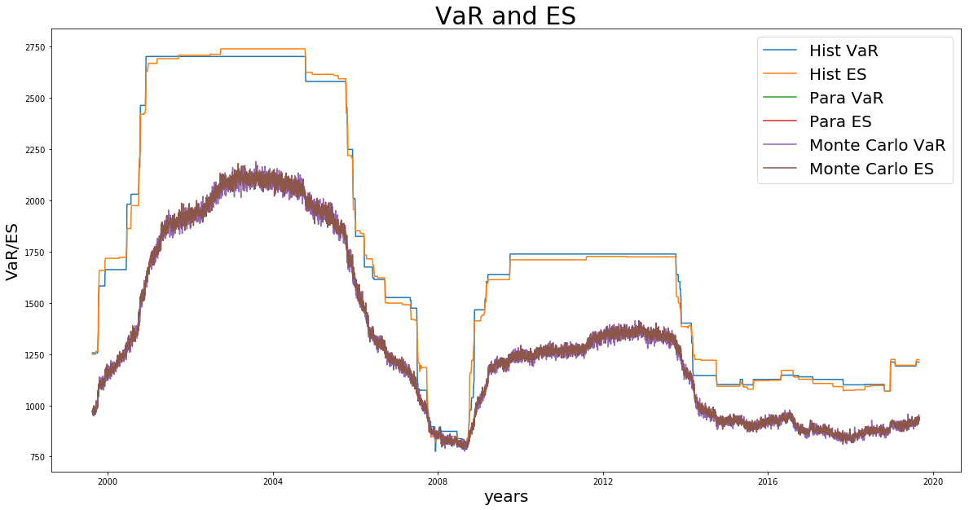

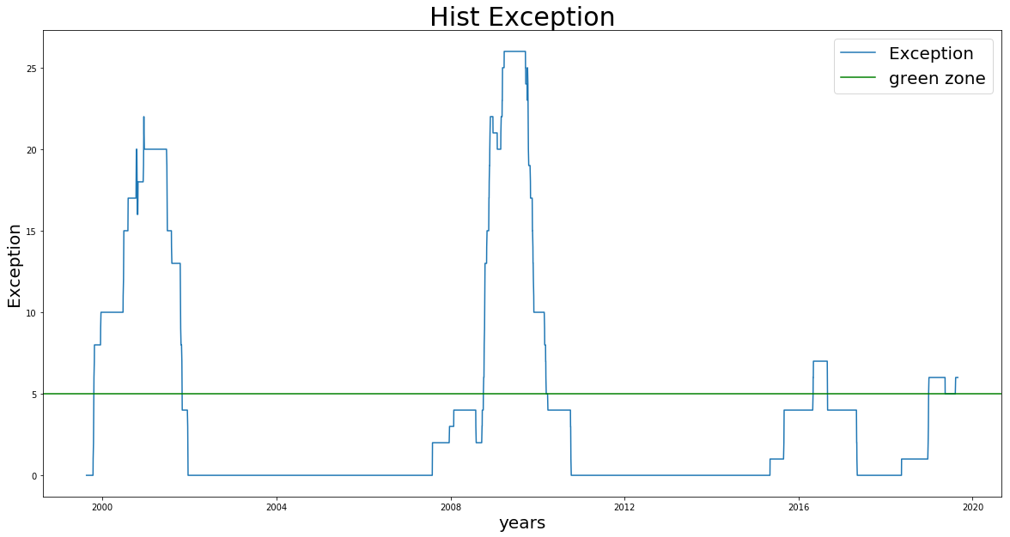

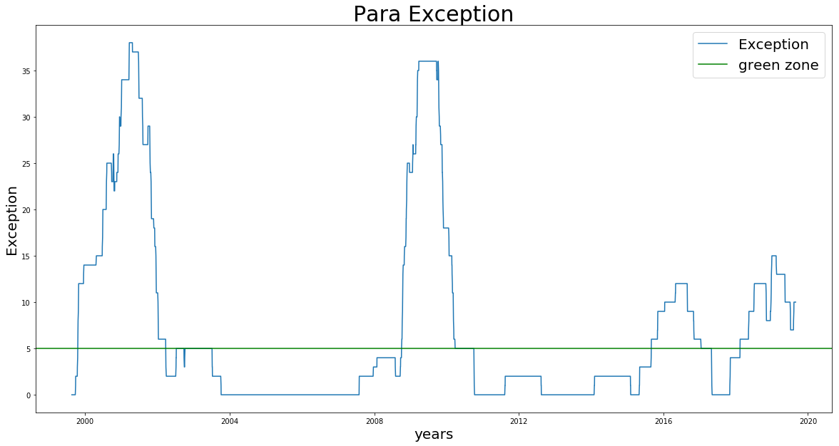

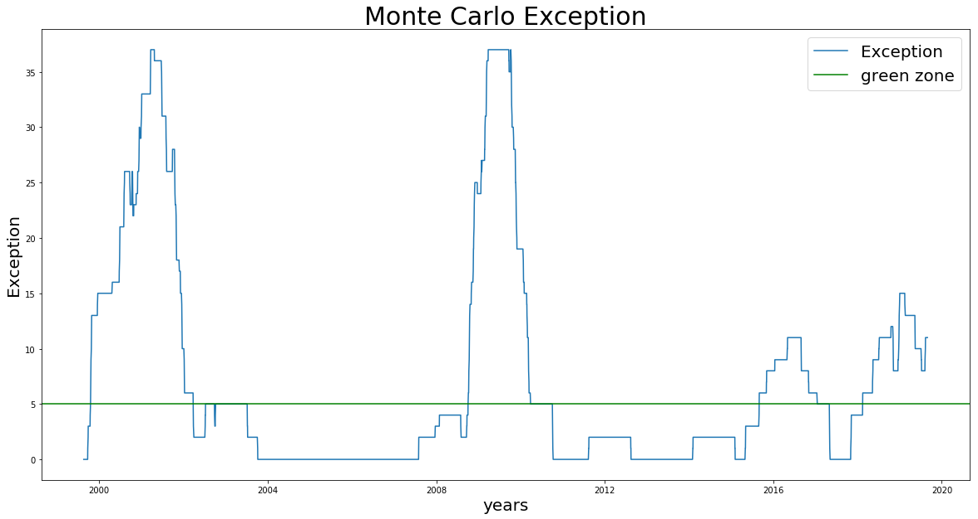

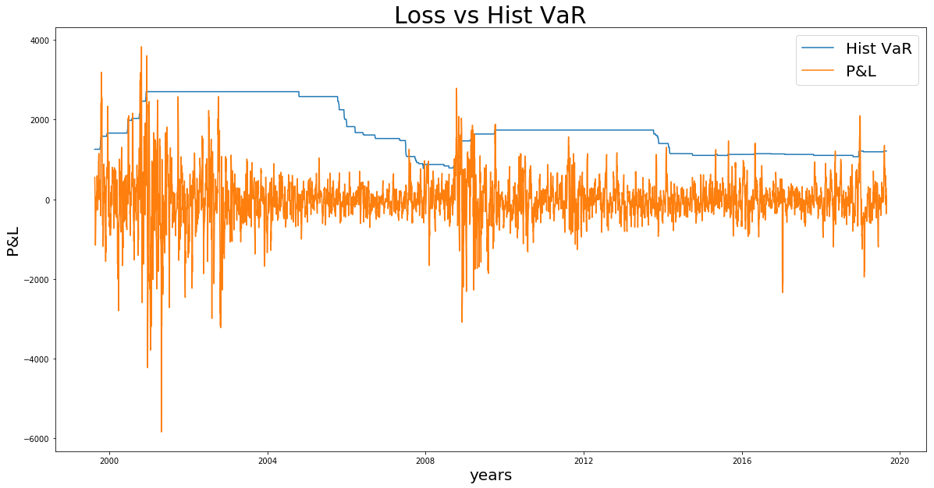

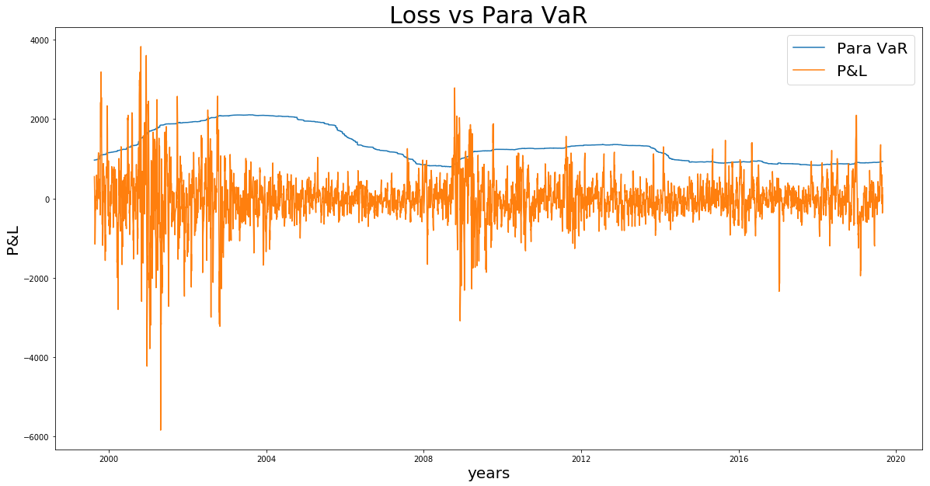

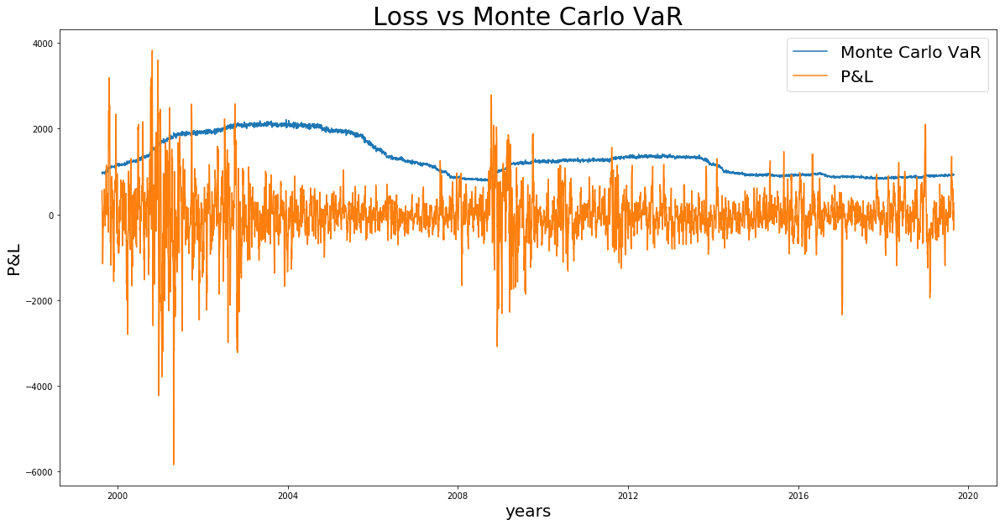

## **All short position on the Xerox Stock**

In the short position, as mention above, the risk is higher compared to the long position. However, due to the Xerox’s stock price precipitously going down in the beginning of 2000, the exception counting is greatly lower at that time, and slightly lower in 2008 because of a smaller change.

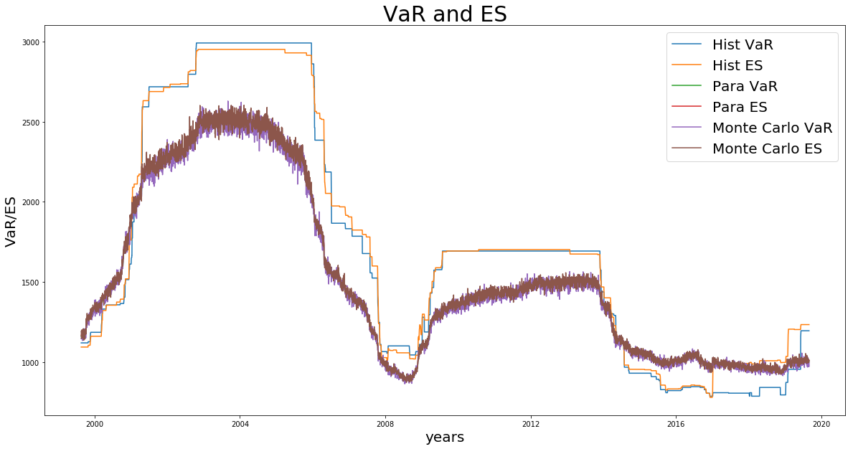

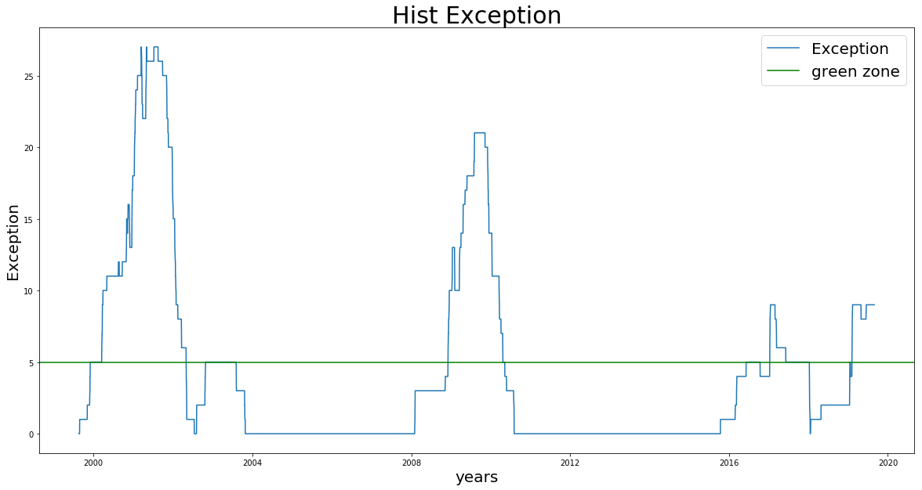

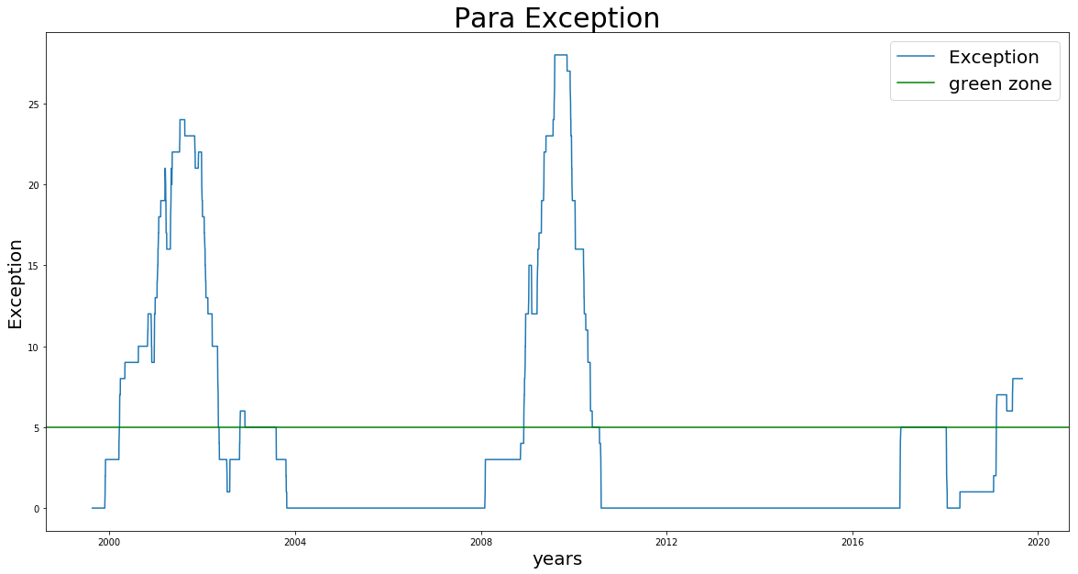

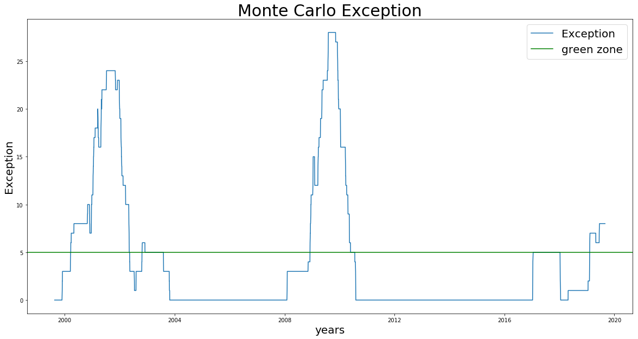

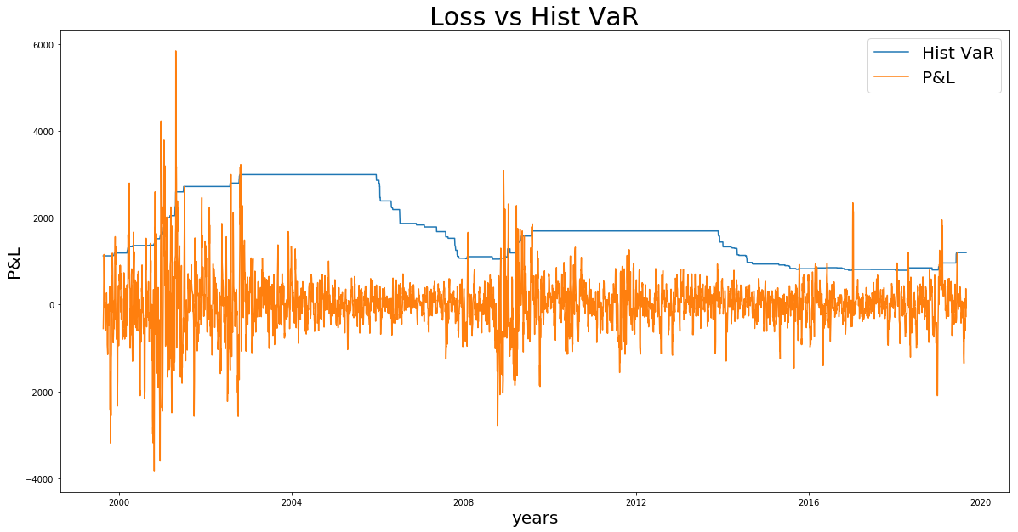

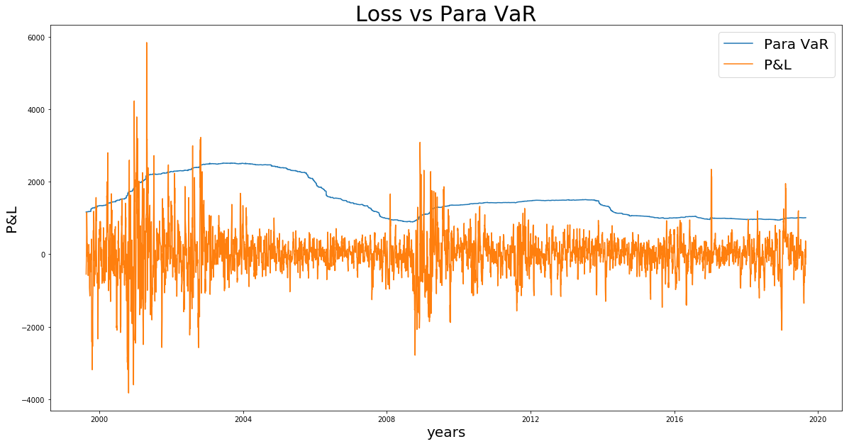

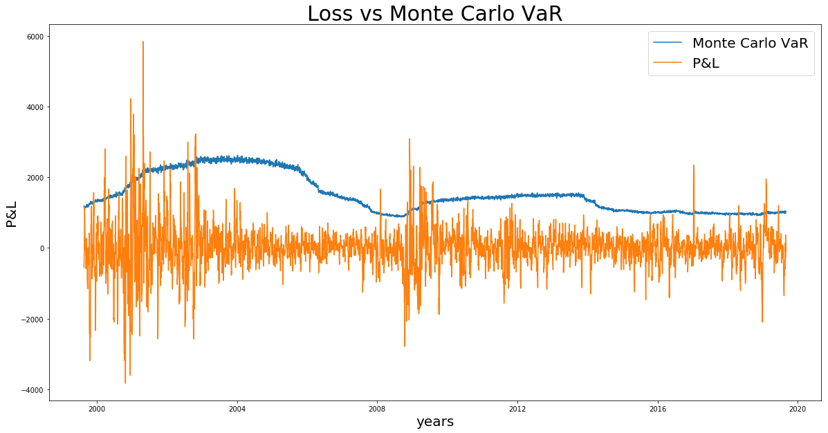

## **50% position on Ford and 50% position on Xerox, portfolio in long position**

This composition comes directly from the homework assignment where we spilt the position into two stocks. VaR and ES went higher in 2000 under dot com bubble burst and 2008 financial crisis. As can been seen, 2008 stills take a higher spike at nearly 45 exceptions in the long position when the portfolio’s price going down, whereas in 2000, the souring price in Ford’s stock partially offset the downturn of the Xerox’s stock.

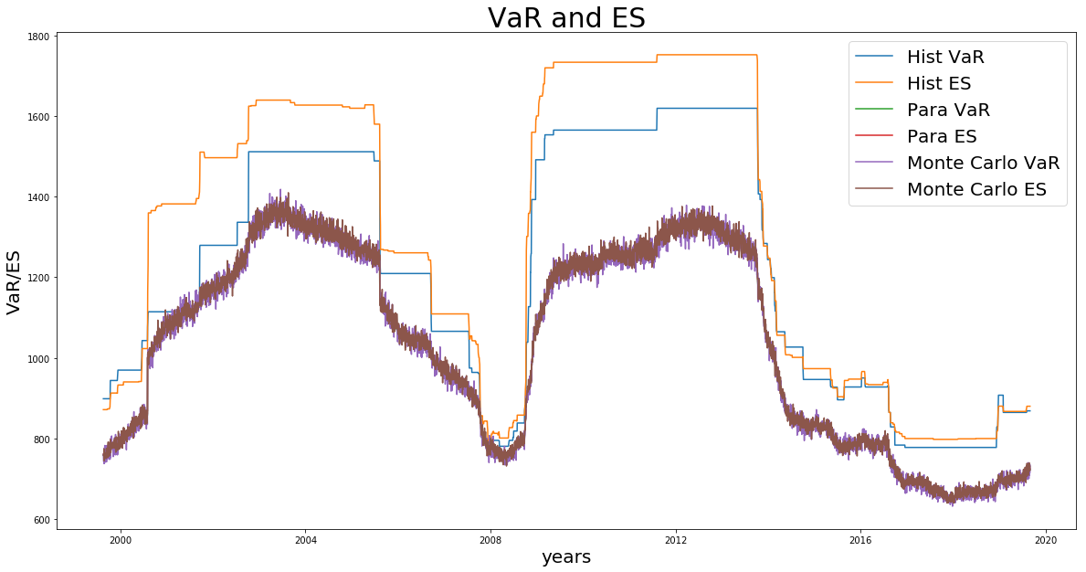

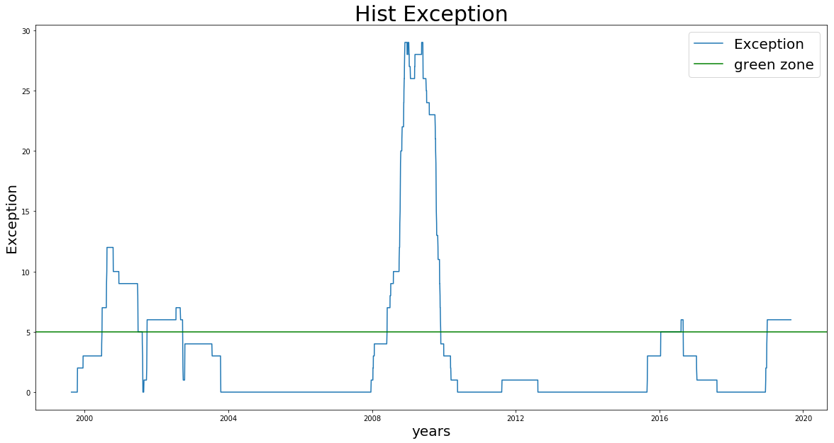

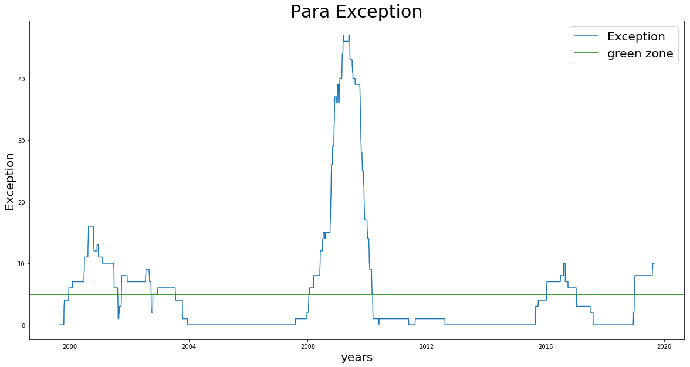

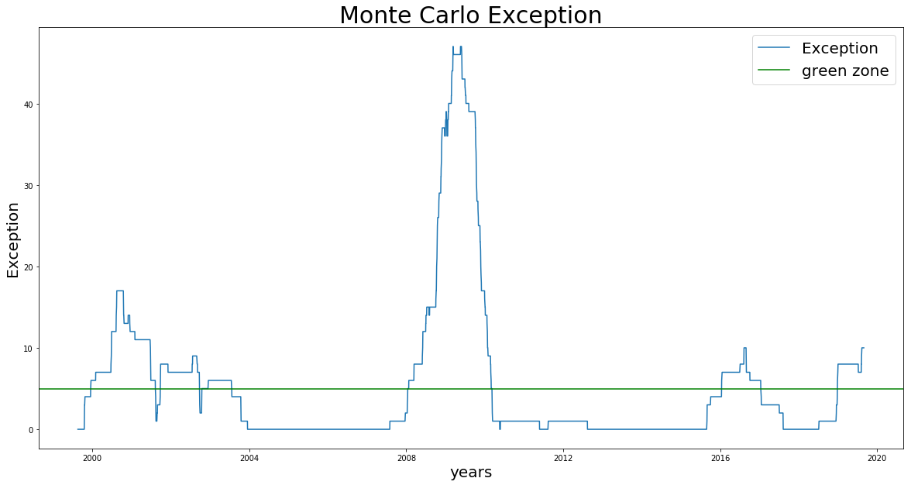

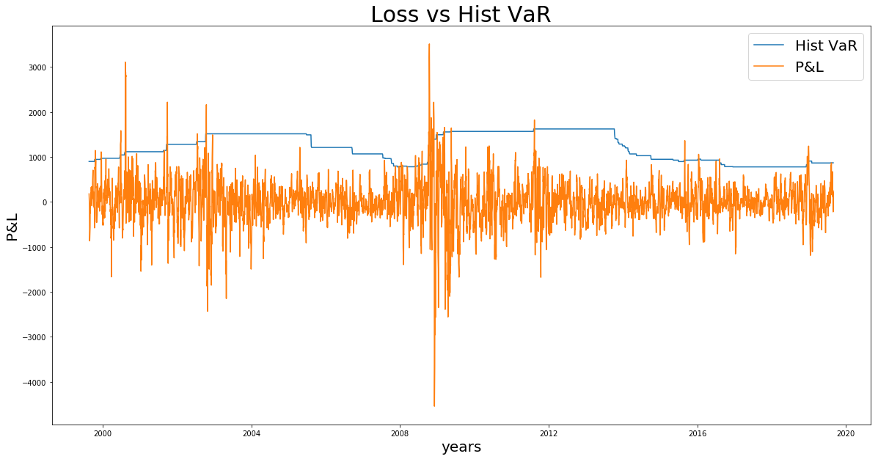

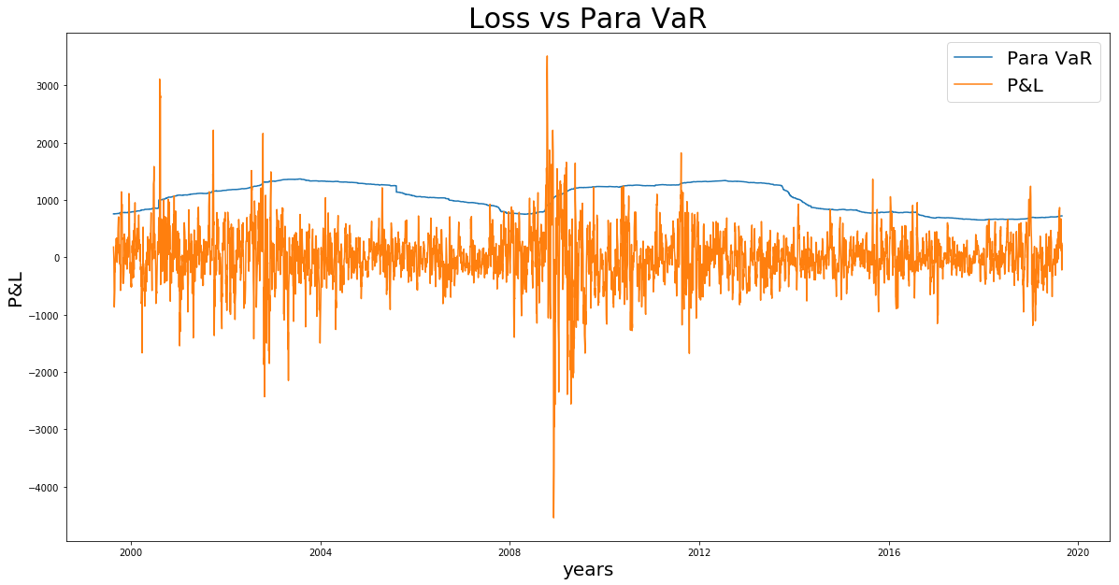

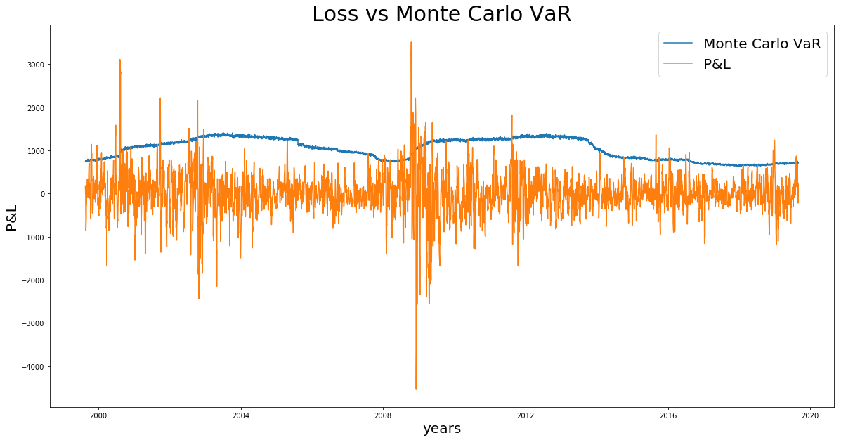

## **50% position on Ford and 50% position on Xerox, portfolio in short position**

The total short position yields a lower exceptions in 2008 Financial Crisis. However, the first spike appears to be post dot com bubble burst. This is due to the recovery of the market and the rise of the portfolio’s price as losses incurs in the short position to which Ford stock attributes most.

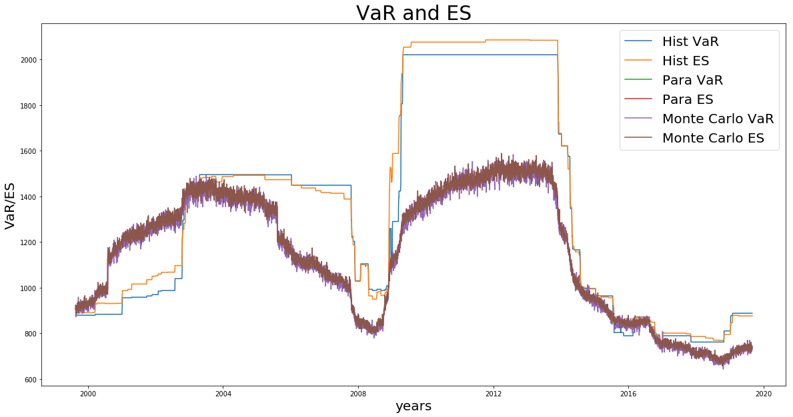

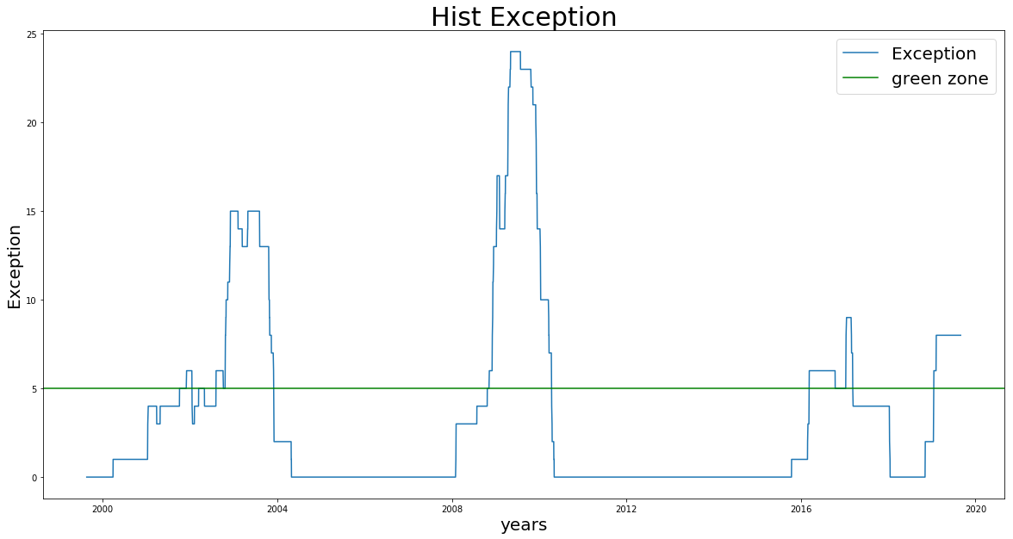

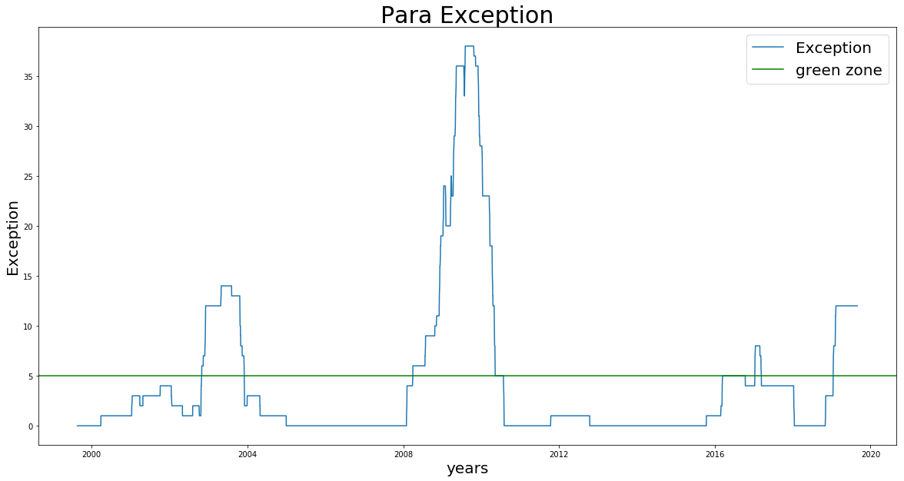

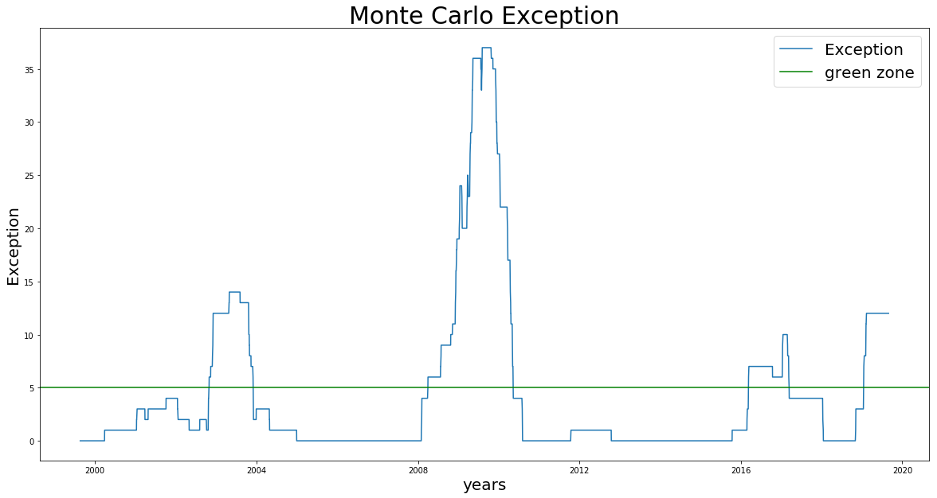

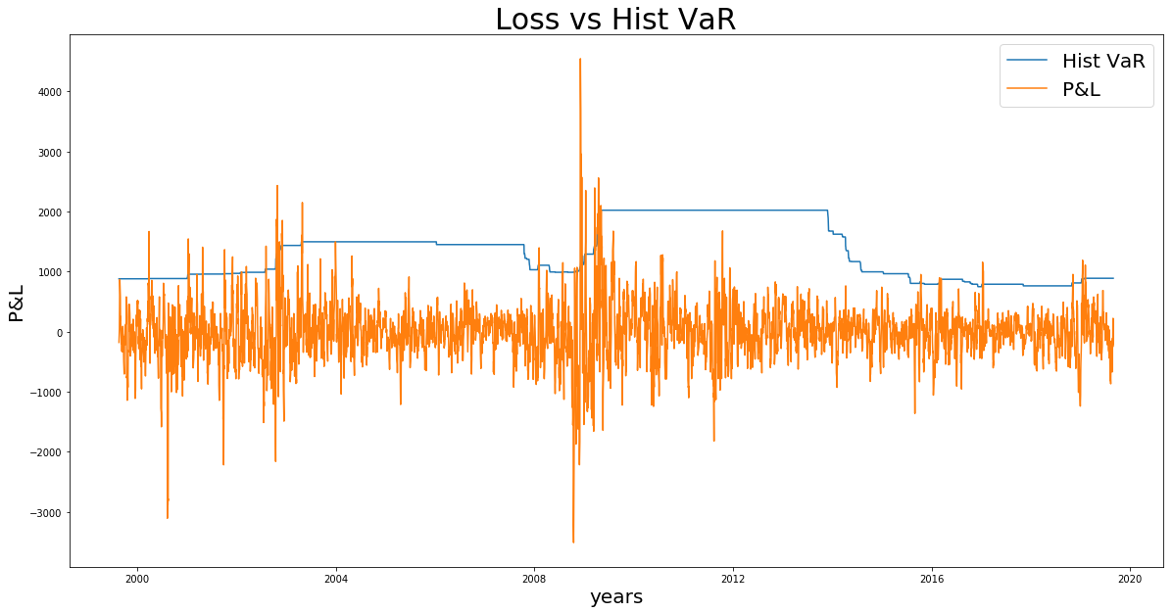

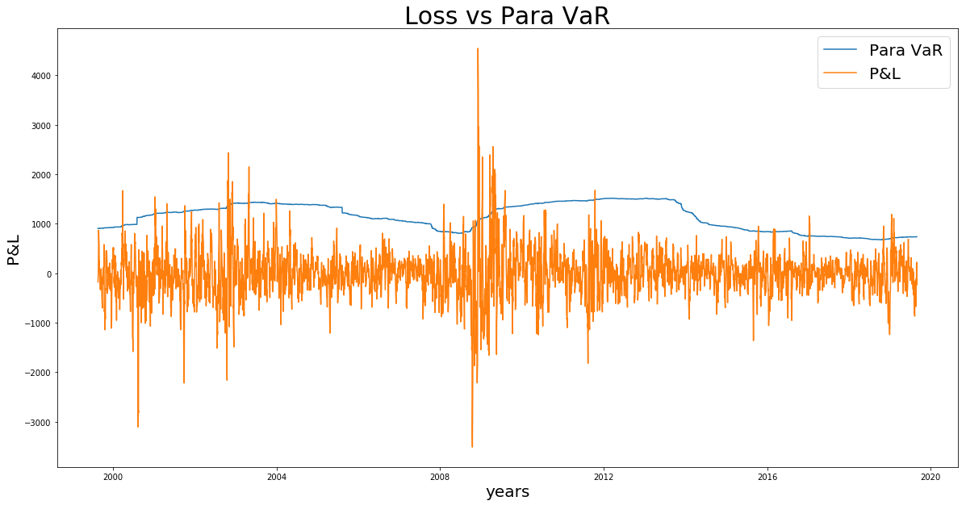

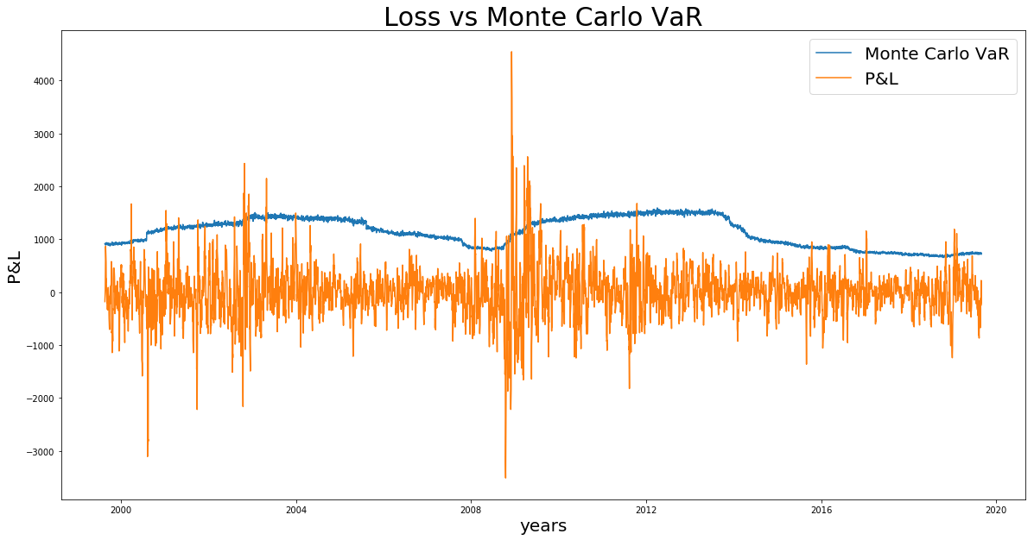

## **45% position on Ford and 50% position on Xerox, with 5% position on S&P 500 put options, portfolio in long position**

This case now takes into consideration the S&P 500 put options with 5% position. Since S&P 500 has a positive correlation with Ford stock and Xerox stock, if stock price goes down, S&P 500 has almost the same trend in decreasing as well. As a result, put option would be more valuable and a long position in the put option could offset the losses from the long position in the stock. This could better explain a lower VaR and ES in this portfolio compared to the ones without any put option. Besides, the spike of the exception during 2000 and 2008 is lower due to the hedge effect from the put option.

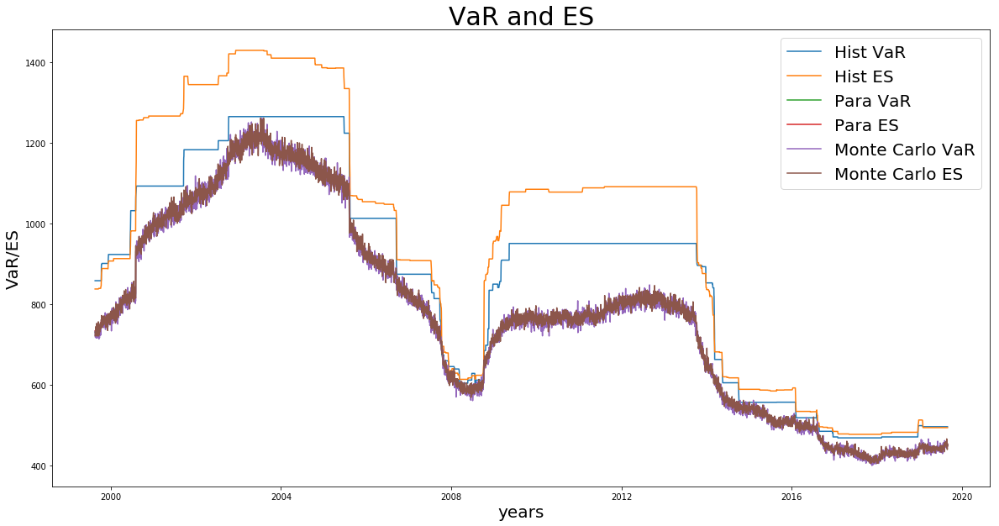

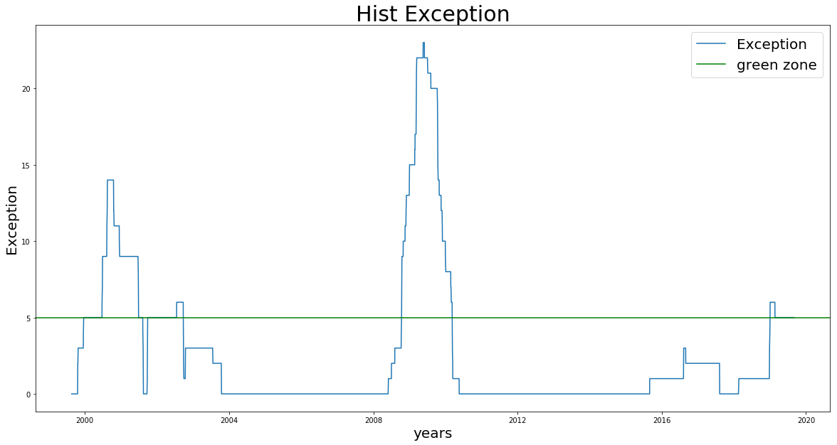

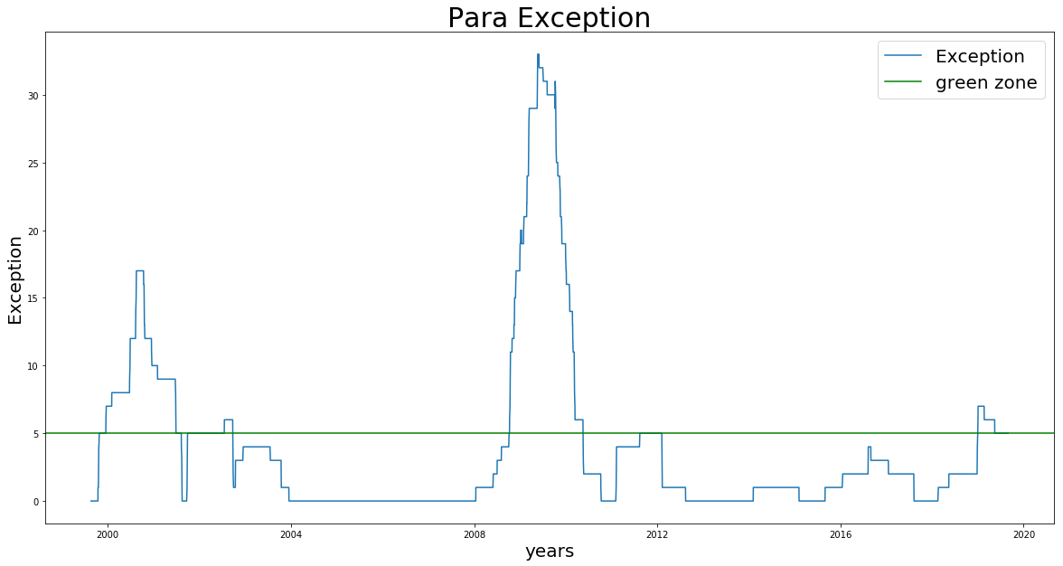

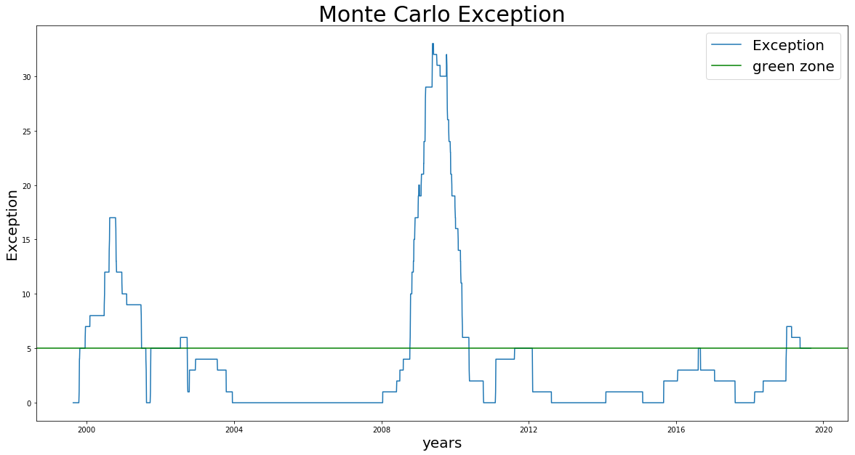

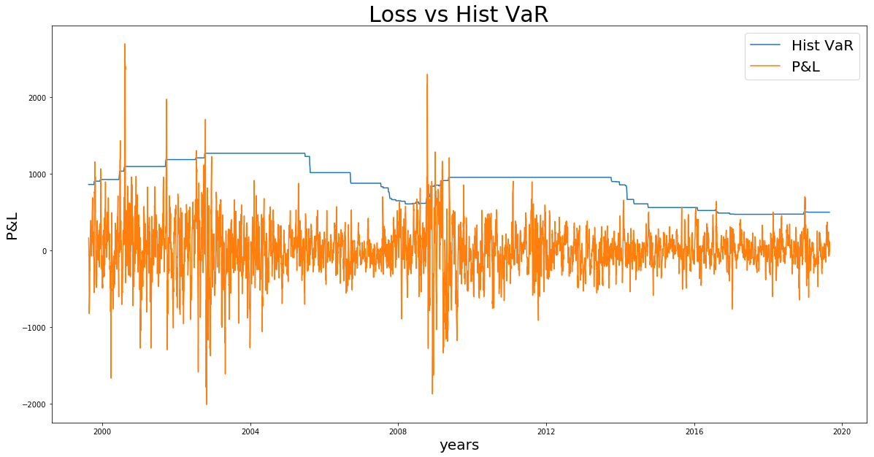

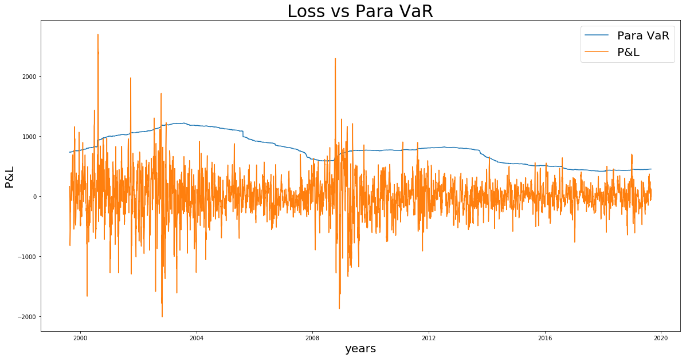

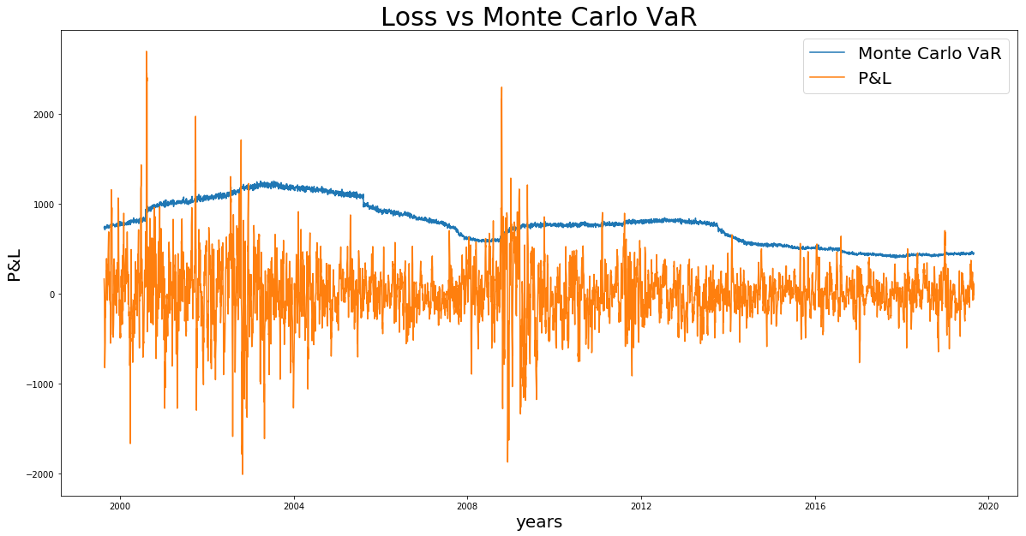

## **45% position on Ford and 50% position on Xerox, with 5% position on S&P 500 put options, portfolio in short position**

We could also have a case in the short position of the whole portfolio. When short the stock and options, the portfolio writer (seller of the portfolio) has a confidence that the stock market is likely to go down, even though the put option’s price will increase; however, a loss will incur when the stock market goes up, it could be recovered by the profit from the put option whose price decrease.

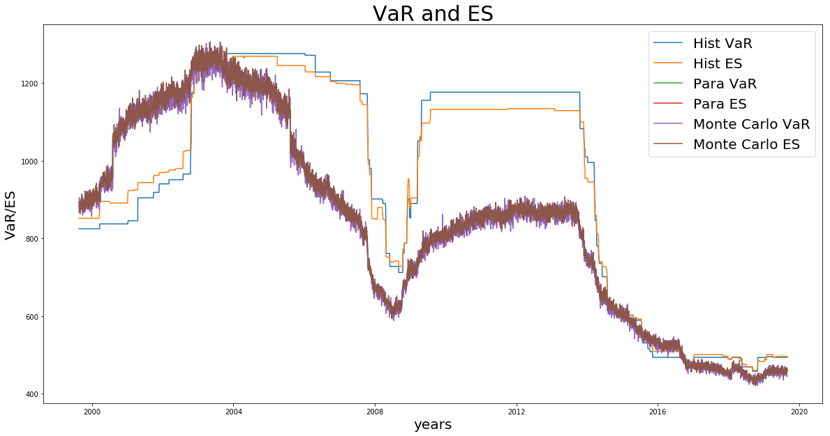

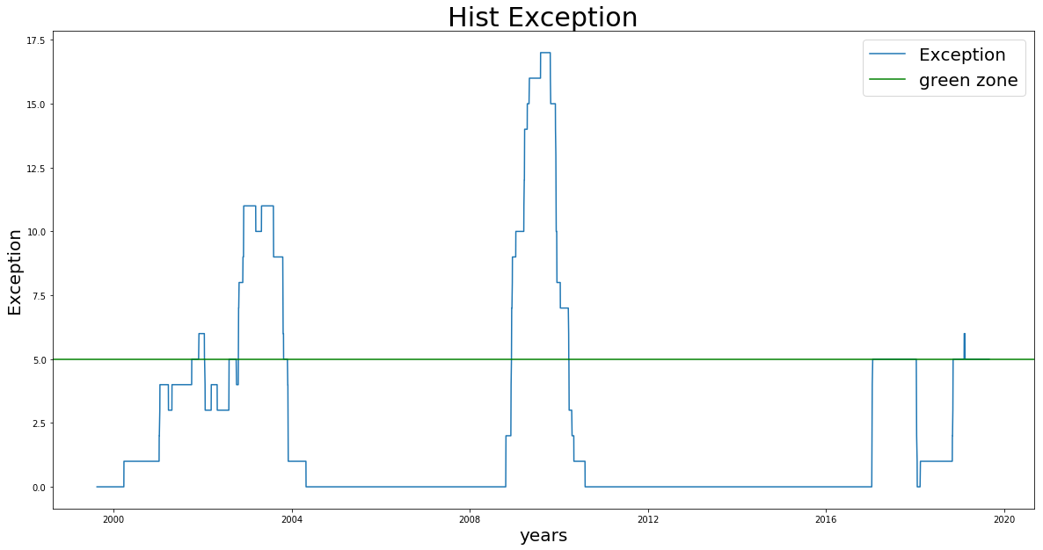

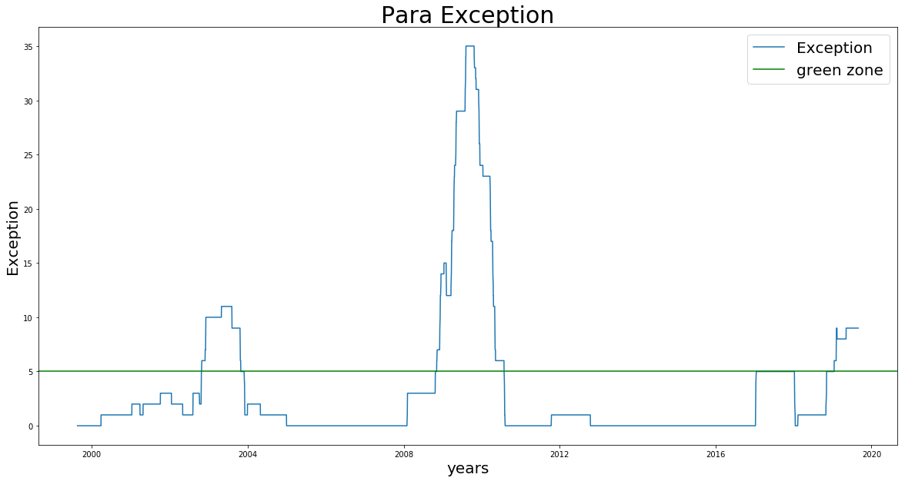

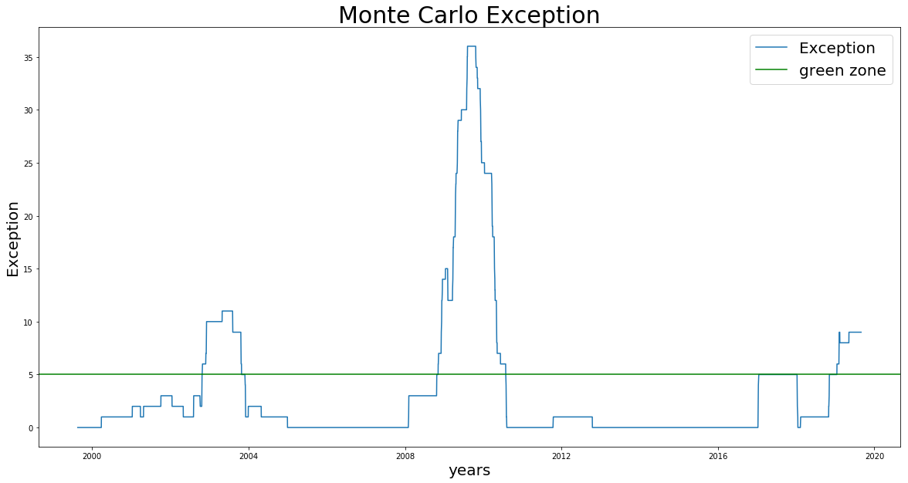

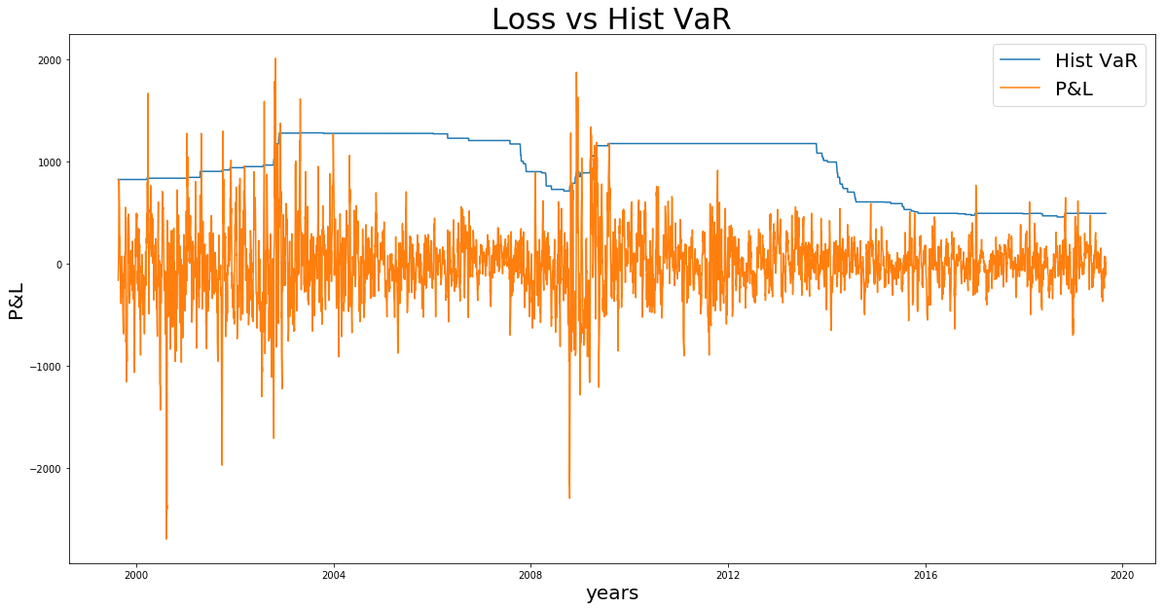

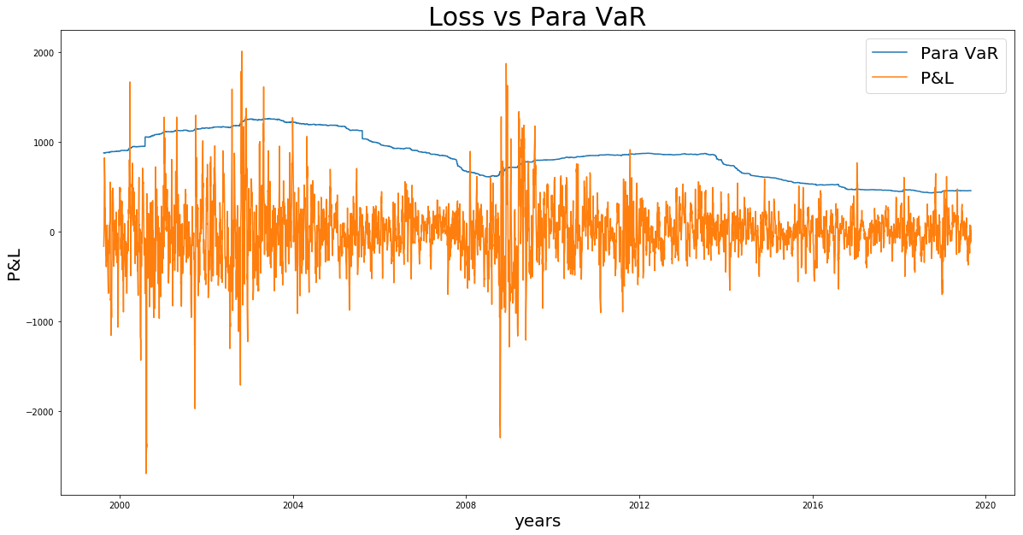

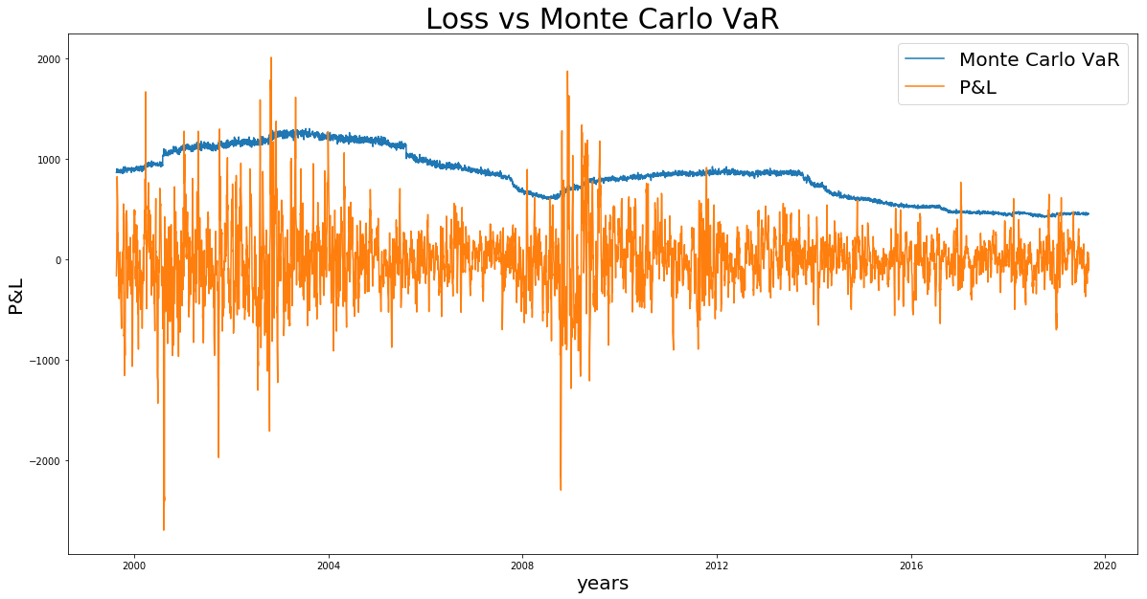

# **Recommendation**

For a robust model implementation, it should execute Monte Carlo Simulation by taking into consideration the correlation between Ford stock, Xerox stock and S&P 500 Index, where Stock price and Index can be simulated by 10000 paths, and Stock price and Option price can be simulated as a result so that 10000 paths’ P&L will be generated for VaR and ES calculation. This implementation can avoid an underestimation of the VaR in a bid for a more conservative risk measurement, and also feasible application for VaR risk measurement of nonlinear payoff derivatives such as Option contracts.